4.3. Design and Analysis of an FIR Low-Pass Filter Using the Hanning Window Technique in MATLAB

CODING:
clc;
clear;
close all;

%% --- Input Parameters ---
fp = 1000; % Passband cutoff (Hz)
fs = 4000; % Sampling frequency (Hz)
N = 50; % Filter order (even number preferred)

wc = fp/(fs/2); % Normalized cutoff frequency (0 to 1)

%% --- FIR Low Pass using Hanning Window ---
b_hann = fir1(N, wc, 'low', hanning(N+1));

disp('--- Hanning Window Coefficients ---');
disp(b_hann');

%% --- Plot Frequency Responses ---
figure;
freqz(b_hann,1);
title('Low-pass FIR using Hanning Window');

OUTPUT: 1
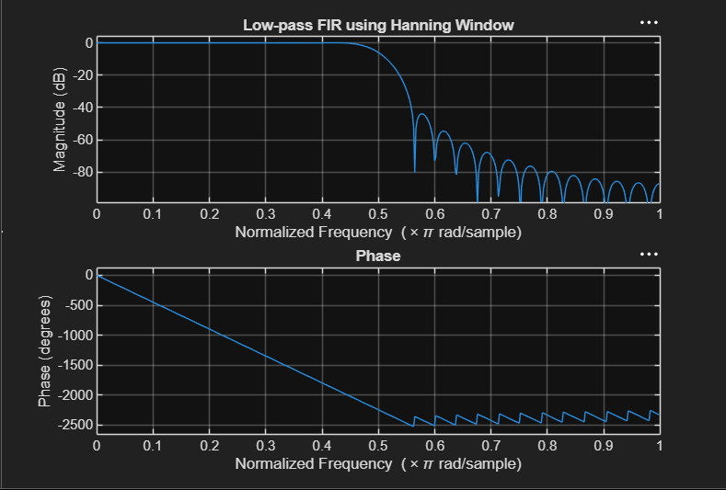

RESULT:
Hanning Window Coefficients ---
0.0000
0
-0.0004
0
0.0013
0
-0.0028
0
0.0050
0
-0.0081
0
0.0122
0
-0.0179
0
0.0259
0
-0.0378
0
0.0580
0
-0.1027
0
0.3172
0.5000
0.3172
0
-0.1027
0
0.0580
0
-0.0378
0
0.0259
0
-0.0179
0
0.0122
0
-0.0081
0
0.0050
0
-0.0028
0
0.0013
0
-0.0004
0
0.0000

